**Assignment – 20**

**Changing Values through Views.**

1) Which of these views are updateable (will allow DML operations)?

#1 Create View Dailyorders

as Select Distinct cnum, snum, onum, odate from Orders;

#2 Create View Custotals

as Select cname, Sum (amt) Sum_Amt from Orders, Customers

where Orders.cnum=Customers.cnum

Group by cname;

#3 Create view Thirdorders

as Select * from Dailyorders where

odate=’1990-10-03’;

#4 Create view Nullcities

as Select snum, sname, city

from Salespeople

where city is NULL

OR sname BETWEEN ‘A’ and ‘MZ’;

* **#4 Create view Nullcities**
* **as Select snum, sname, city**
* **from Salespeople**
* **where city is NULL**
* **OR sname BETWEEN ‘A’ and ‘MZ’;**

**This view is updatable as,**

**Based on a single table (Salespeople).**

**No DISTINCT, GROUP BY, or Aggregate Functions.**

**Only Uses a WHERE Clause, which doesn't prevent updates.**

Create a view of the Salespeople table called Commissions. This view will include

only the snum and comm fields. Through this view, someone could enter or change

commissions, but only to values between .10 and .20.

**create view commissions**

**as**

**select snum, comm from salespeople**

**where comm between 0.1 and 0.2;**

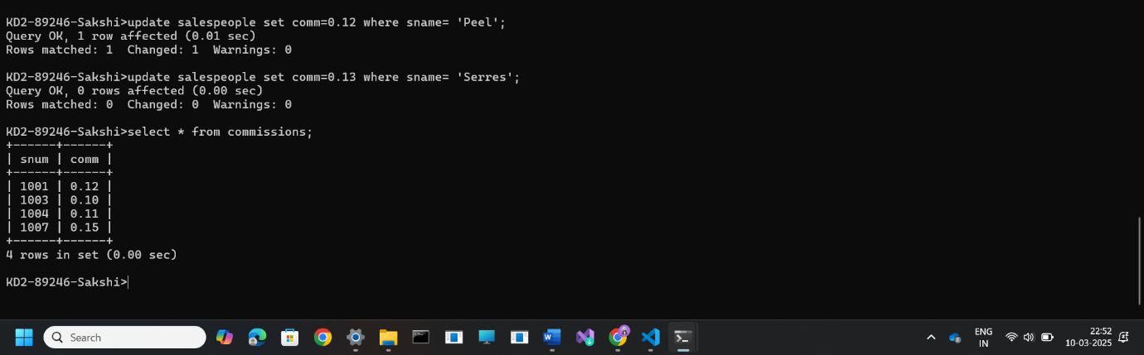

3) Some SQL implementations have a built-in constant representing the current date,

sometimes called “CURDATE” or “SYSDATE”. The word SYSDATE can

therefore be used in a SQL statement, and be replaced by the current date when the

value is accessed by commands such as Select or Insert. We will use a view of the

Orders table called Entryorders to insert rows into the Orders table. Create the

Orders table, so that SYSDATE is automatically inserted for odate if no value is

given. Then create the Entryorders view so that no values can be given.

**Create table Entryorders(**

**Onum int primary key,**

**Amt float(7,2),**

**Cnum int not null,**

**Snum int not null,**

**Odate date default sysdate()**

**);**

**Create view Entryorders**

**As**

**Select * from Entryorders;**